Title: Day 8 – IoT Smart Home Dashboard (Testing Phase using JUnit)
Date: 26 Sept 2025
Name: Nihar Ashraf

Introduction:
On Day 8, the focus was on testing and validating the complete functionality of the IoT Smart Home Dashboard application using the JUnit testing framework.
The objective was to ensure that all modules — Authentication, Gadget Management, Device Status Updates, and Telemetry Logging — perform correctly and that data integrity is maintained between MySQL (SQL) and DynamoDB (NoSQL) databases.

Activities Performed:
- JUnit Setup in Maven Project
- Added JUnit 5 dependency in pom.xml for automated testing.
- Created directory structure under:
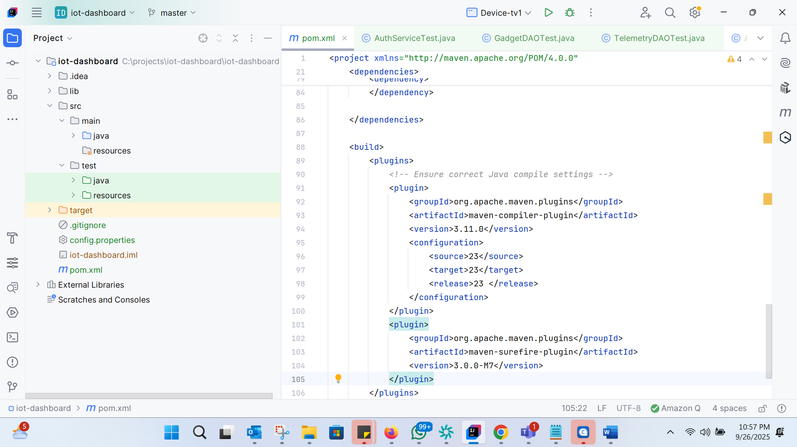
- Configured config.properties and test_schema.sql to use a dedicated test database for safe testing.

- Test Cases Implemented
- Four main test files were implemented and executed successfully:
Test Class | Description | Result
AuthServiceTest.java | Validates password hashing and verification using AuthService. | ✅ Passed
GadgetDAOTest.java | Verifies gadget creation, reading, updating, and deletion operations in MySQL. | ✅ Passed
UpdateGadgetStatusTest.java | Checks if device ON/OFF status updates both in MySQL and DynamoDB Telemetry. | ✅ Passed
TelemetryDAOTest.java | Tests insertion of telemetry records in DynamoDB. | ✅ Passed

- Local DynamoDB Testing
- Launched DynamoDB Local on http://localhost:8000.
- Verified telemetry records were stored successfully with the following attributes:
  - device_id
  - metric
  - value
  - owner_id
  - ts (timestamp — converted to human-readable date/time format)

- Test Execution
  - All tests executed successfully with a green bar in CMD Prompt and a “BUILD SUCCESS” message in the terminal.

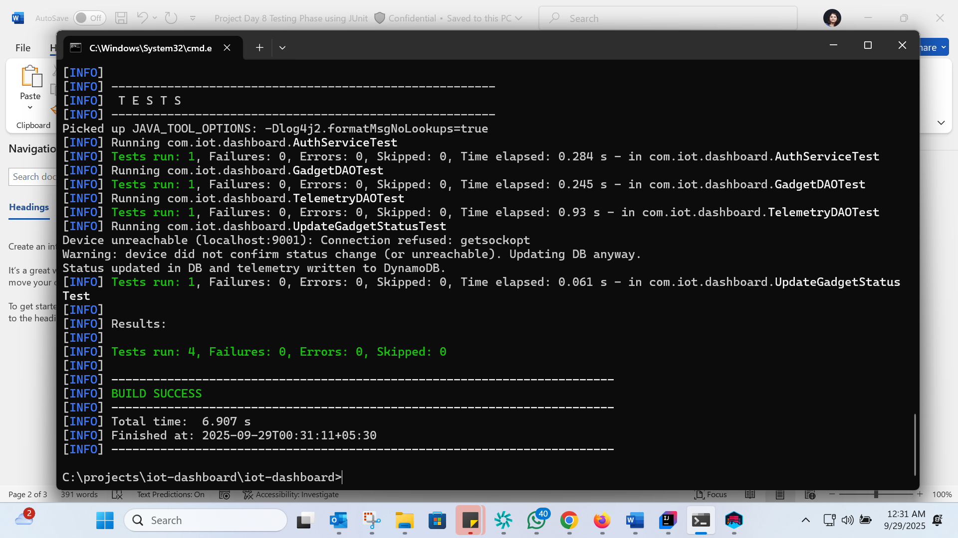

Results and Observations:
- All the core modules of the IoT Dashboard are functioning properly.
- Passwords are securely hashed and verified.
- Device and Gadget data sync between MySQL and DynamoDB is working as expected.
- The timestamp issue was resolved by converting epoch milliseconds to readable date format.
- Error handling works well — unreachable devices, ownership mismatches, and invalid logins are handled gracefully.

Learnings:
- Gained hands-on experience in writing and executing JUnit test cases.
- Improved understanding of SQL–NoSQL data consistency in IoT systems.
- Reinforced knowledge of test-driven development (TDD) practices.
- Understood the importance of logging and validation in telemetry data flow.

Conclusion:
Day 8 successfully validated the end-to-end reliability and consistency of the IoT Smart Home Dashboard.
All functional modules passed testing with both SQL and NoSQL databases performing accurately.
With testing complete, the system is now stable and fully prepared for Day 9 — Deployment and Demonstration Phase.

